**Assignment-8**

1. What do you mean by AutoComplete feature in Excel and what are the benefits of using this feature?

Ans: Auto-fill is a very useful Excel feature. **AutoComplete helps you quickly insert functions and arguments while minimizing typing and syntax errors**, and helps **create entire columns or rows of data that are based on the specified values from other cells**. In other words, Excel compares the selected data and tries to guess the next values that will be inserted

1. Explain working with workbooks and working with cells.

Ans: Excel file, often referred to as a workbook, contains one or more spreadsheets, or worksheets. Each box in the worksheet area is referred to as a cell. Each cell has a cell address, which is composed of a column reference and a row reference.

1. What is fill handle in Excel and why do we use it?

Ans: The fill handle is a tool in [Microsoft Excel](https://www.webopedia.com/definitions/microsoft-excel/) that helps improve productivity. This feature makes it possible to fill an entire section of cells with the same [data](https://www.webopedia.com/definitions/data/) or [formula](https://www.webopedia.com/definitions/formula/). Alternatively, the fill handle can also detect and reproduce formatting and read patterns in the data, text, or formula to replicate those across a selection of cells.

* **Select the cell that has the formula or data you want to fill in other cells.**
* **Hover your cursor over the bottom right corner of the cell until it turns into a black plus sign.**
* **Click and drag the fill tool up, down, left, or right.**
* **Let go of the cursor to fill cells.**
* **To customize the fill style, click the Auto Fill Options box that appears at the bottom right when you release the cursor.**

Fill Handle to Autofill the Number Series Pattern Using Drag and Drop.

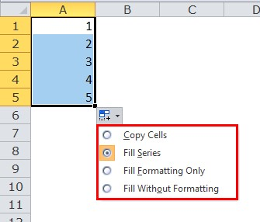

1. Give some examples of using the fill handle.

Ans: Here are few examples:

* 1. **Copy Cells:** This option simply copy-pastes the value of the selected cells.
  2. **Fill Series:** This option fills the cells as a series with increments of 1.
  3. **Fill Formatting Only:** This option only fills the formatting in the cells rather than values.
  4. **Fill without Formatting:** This option fills the cells based on the value pattern without copying the formatting.
  5. **Fill Days:** This option fills the cells with a series of days’ names.
  6. **Fill Weekdays**: This option fills the cells with the days’ names except for the weekends (Sat and Sun).
  7. **Fill Months:** This option creates the list by incrementing the months only and the date and year remain constant.
  8. **Fill Years:** This option creates the list by incrementing the years only and the date and month remain constant.

1. Describe flash fill and what the different ways to access the flash fill are.

Flash Fill automatically fills your data when it senses a pattern. For example, you can use Flash Fill to separate first and last names from a single column, or combine first and last names from two different columns. Shortcut key= Ctrl + E

